|  |  |  |  |  |  |  |  |
| --- | --- | --- | --- | --- | --- | --- | --- |
| Capstone Project Step-by-Step Solution | | | | | |  | Task |
| 2 |
|  | | | | |  |  |  |
|  |  |  |  |  | | |
|  | | | | |  |  |

Create a new user group, add group members, and modify the Incident form so that it shows a new field.

**Refer to** Module 3: Configure Applications for Business.

1. Manage Users, Groups, and Roles

Create a new user group called Strawberry Support and add members to it.

1. Navigate to **All > User Administration > Groups**.
2. Open the **Service Desk** record.
3. Select the **Groups** tab.



1. Click **New** to add a new group to Service Desk.
2. Populate the record as follows:  
     
   Name: **Strawberry Support**Manager: **Fred Luddy**
3. Click the **Additional Options Menu**, then select **Save**.

**NOTE**: You may see a number of blue messages appear on the form as you work through these task steps. It is OK to close them.

1. Select the **Roles** tab, then click **Edit**.
2. Add the **itil** role to the Strawberry Support Roles List.
3. Click **Save**.
4. Select the **Group Members** tab, then click **Edit**.
5. Add the following users to the Strawberry Support group:

* Beth Anglin
* Bud Richman
* David Loo
* Waldo Edberg

1. Click **Save**.
2. Select the **Group Members** tab, then click **New**.
3. Populate the form as follows:   
     
   User ID: **kara.prince**  
   First name: **Kara**  
   Last name: **Prince**  
   Email: **kara.prince@cloudd.com**

**NOTE:** Creating a user from the group record will automatically add them to the group.

1. **Save** the record, do not Submit.
2. Set Manager Values
3. From the User record, open the **Additional Options Menu**, then select **Configure > Form Layout**.
4. Add the **Manager** field to the **Selected** column. Move it beneath the **Department** field.
5. Click **Save**.
6. From the User record, select **Fred Luddy** as Kara’s manager.
7. Click **Update**.

TASK VERIFICATION

The list of the Strawberry Support group members should look like this:

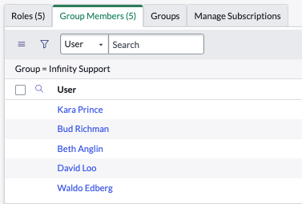

**NOTE:** The list of Strawberry Support group members may be in a different order than shown.